



Using the Magic Pocket: A Dropbox Guide
By Matt Smith http://smidgenpc.com/

Edited by Justin Pot

This manual is the intellectual property of MakeUseOf. It must only be published in its original form. Using parts or republishing altered parts of this guide is prohibited without permission from MakeUseOf.

Table of Contents
Chapter 1: An Introduction to Dropbox 4
What is Dropbox? 4
Free and Paid Dropbox Plans 5
Dropbox Clients for Everything 5
System Requirements 6
Installation 7
Chapter 2: Syncing Files 9
Cloud Storage and Dropbox – What it all means 9
The Dropbox Folder 10
File Sync Details 12
File Sync on Mobile Devices 13
Chapter 3: The Web Interface 15
Logging in and Exploring the Web Interface 15
Accessing Files and Folders with the Web Interface 16
Events, Sharing and Help! 17
Chapter 4: File Sharing 19
The Basics of Dropbox File Sharing 19
Public Folder File Sharing 20
Sharing Files with Individuals 21
Chapter 5: Online Backup 24
The Pros and Cons of Online Backup 24
Handling Space and Security 25
Using the Undo/Undelete Feature 26
Chapter 7: Advanced Dropbox Tricks 28
Syncing Calendars, Email and More 28
Using Dropbox as a Remote Control 29
Syncing Wikis and To-Do Lists 29
Other Tips, Tricks and Hacks 30
Chapter 8: Conclusion 32
Additional Dropbox Reading 32
Competitors and Alternatives 32
Happy Dropbox-ing! 33
Chapter 1: Intro to Dropbox

What is Dropbox?

You’re at the coffee shop. You need to access a file that has information about your work, but as you attempt to find the file you realize that you’ve made a mistake. You saved the work on your desktop computer, but you only have your laptop with you. You have no way to access the file.

This problem, and others like it, are increasingly common today. It isn’t unusual to own both a desktop and a laptop computer, and a smartphone on top of that.
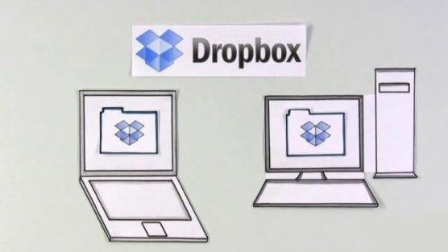
The convenience of being able to relax at a coffee shop while working on your laptop and checking movie times on your smartphone is attractive, but it makes organizing your files difficult. You may find yourself frequently emailing files to yourself, or dragging files back and forth from a USB drive. This only works as well as your own memory: if you forget to transfer files you will find yourself up a creek without a paddle.

Dropbox solves these issues by making it easy to synchronize files between computers. Installing Dropbox creates a special folder on your computer. Anything that you put in this folder is automatically synchronized with any other computer on which you’ve installed the service. The files you drop in for synchronization are also located on a remote server, which means you can download news files even when all of your other devices are turned off or offline.

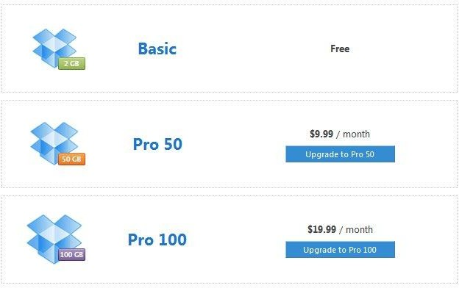
Free and Paid Dropbox Plans
There is only one version of the Dropbox client, and its functionality is the same for all users. However, the cloud nature of the service makes it necessary for Dropbox to charge users who need a lot of storage space.

There are currently three Dropbox plans: the free plan, which offers two gigabytes of storage space; the Pro 50 plan, which offers 50 gigabytes of storage and is priced at
$9.99 per month; and the Pro 100, which predictably offers 100 gigabytes of space and is priced at $19.99 per month.

Dropbox Clients for Everything

One of the greatest strengths of Dropbox is the large number of platforms its supports. Personal computers running Linux, OS X and Windows are all supported. This would normally be considered very good, but Dropbox takes things a step further by offering support for mobile devices.

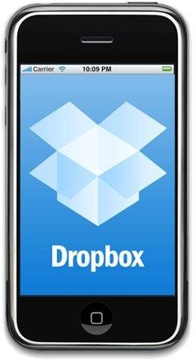
The mobile devices currently supported include Android smartphones, iPhones and iPads. Support for Blackberry has been publicly announced but not yet finished (as of November 2010). All of the mobile Dropbox applications are every bit as free as the PC client and provide full
functionality – although the types of files that can be successfully opened on your smartphone will depend on the smartphone’s software support.
You can also access the Dropbox website at any time from any device that has a web browser. This makes it possible to access the files in your Dropbox folder without having to install the software – handy if you’re at a friend’s house and you want to show off some photos. Just log in and use the web interface.

System Requirements

The Dropbox software is very light, so you don’t need a beefy computer in order to use it. The system requirements are as follows:

- RAM: At least 512MB
- Hard Drive Space: At least equal to your Dropbox storage limit
- Operating System: Windows 2003, Windows XP, Windows Vista, Windows 7, Mac OS X 10.4+, Ubuntu 7.10+, Fedora Core 9+

The Dropbox iPhone app has the following requirements:

- iPhone OS v3.1 or later
- Apple ID with access to the App Store

The Dropbox Android app has the following requirements:

- Android OS 1.5 or later
- 2MB of free space
- SD card of any size

Dropbox’s website is also an important part of the service. To use it you’ll need to have Internet Explorer 7+, Safari 3+, Firefox 3+ or Opera 9+.

Mobile devices without a client can access the Dropbox mobile site at m.dropbox.com.

Installation

The installation of Dropbox, on any device, is straightforward. You will be asked to create a Dropbox account during installation, or to enter your username and password if you have already signed up for the Dropbox service.
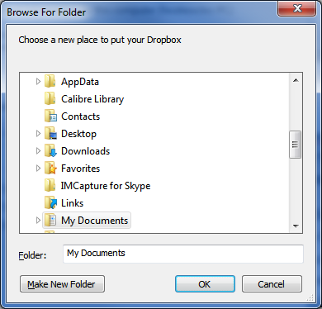
You will also have the option of changing the location of your Dropbox folder. The default location will be fine for most users, but you can place it in any folder that you’d like. You can also change the location of the folder later by accessing the Preferences menu.

It isn’t usually possible to have more than one Dropbox account and folder on a computer. The business model of the service depends on it – if it was easy to have multiple Dropbox accounts operating at once you could simply use twenty-five free accounts instead of paying for the 50GB/month plan. There are ways to game the system, however, as examined in an article on Makeuseof.com. (Link: http://www.makeuseof.com/tag/run-multiple-dropbox-accounts-simultaneously- mac/)

Chapter 2: Syncing Files

Cloud Storage and Dropbox – What it all means

Dropbox is a cloud storage application, so understanding the basics of cloud computing will give you an understanding of how Dropbox works. Cloud storage is a term that unfortunately has been butchered as of late, but at its core the term stands for a very specific way of storing data.

Cloud storage is storage that is not locally hosted. The data is stored in physical media like any other data, but the storage media is a hard drive located in some far-off server farm instead of a hard drive in your computer. You’ll never see the physical device that stores you data or interact with it directly.
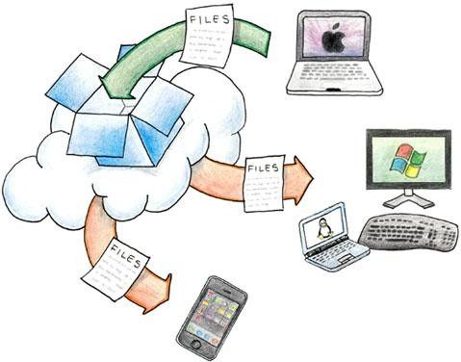

The information that you store is also located on all of your computers that have Dropbox installed, however. This creates a “cloud” of computers, each of which stores the same data and can send that data to any other computer that is part of the cloud. As a result it is no longer strictly accurate to simply say your data is stored on your PC. Instead, the data is stored in the cloud and can be retrieved from the cloud on any computer or mobile device that can access the Internet.

With this said, it should be noted that Dropbox is still not a cloud service if the strictest definition is used, because the synchronization of files on the service ultimately relies on the central server. If the Dropbox servers went down the entire service would be rendered useless until the servers came back online. The data would still be in the cloud – all of your computers have your files – but there would be no way to transfer the files between computers or place new files in the cloud until the server was restored.

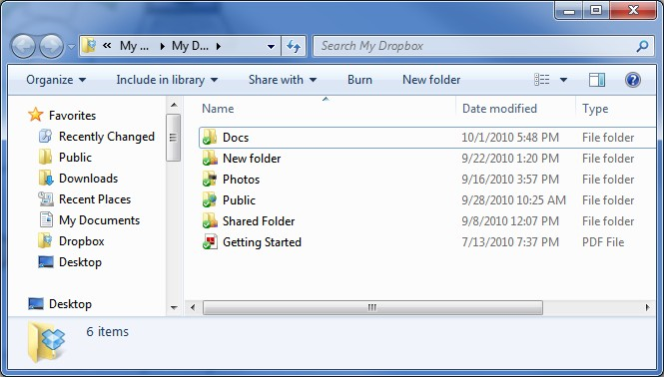
The Dropbox Folder
With that technical bit out of the way, let’s get down to brass tacks and take a look at the most fundamental feature of Dropbox: the Dropbox folder. The account that you create with Dropbox automatically includes a Dropbox folder (you can only have one per account) that shares files with other devices that have the Dropbox client installed and connected to your account.

If you happened to watch the promotional video on the Dropbox website you’ll
know that they refer to their service as a “magic pocket” that is always with you and contains whatever you place in it. This is an apt description. The folder itself looks like a completely normal folder and will be displayed as such on your computer.
Anything that you place into this folder is automatically made available in the

Dropbox folder of any other computer or device that is associated with your account. You don’t have to do anything to make this synchronization occur: just drop the file into the folder the rest happens automatically.

Your Dropbox folder will contain two separate sub-folders when you first open it. The first is called Photos. The Photos folder’s use is obvious – it is meant to store photos!
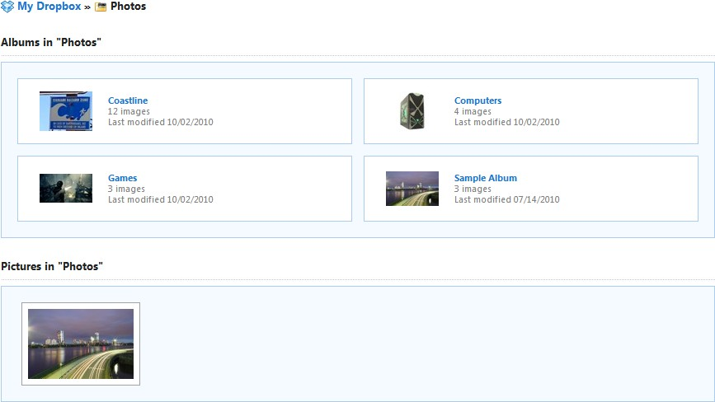
Dropbox includes a Photos folder by default because the service lets you view your photos online by navigating to www.dropbox.com/photos and entering your login information. The photos that you have placed into your Photo folder will be listed in your web browser. The sub-folders in the main Photo folder will be displayed as albums and photos that are not organized into sub-folders will be displayed individually.
The second pre-configured folder is the Public folder. This folder is designed to make sharing individual files easy. This folder, along with Dropbox’s other files sharing features, is explored in Chapter 4 of this guide.

The default Photos and Public folders are important to Dropbox’s functionality and should not be deleted. You can, however, add as many other folders as you’d like. The structure of your folders will be automatically replicated on other devices on which you’ve installed Dropbox. For example, let’s say I create a new folder on my desktop PC called Stuff, and inside that folder I create a sub-folder called Things. A
new folder called Stuff will be automatically created on my laptop, and a sub-folder called Things will automatically be created inside it.

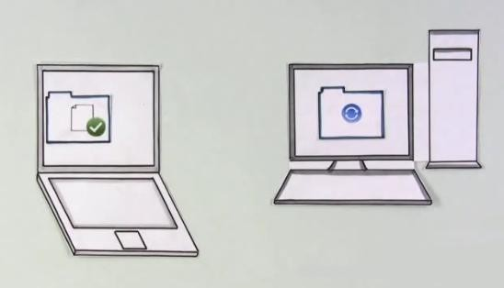
File Sync Details
Dropbox uses an automatic method of file synchronization. When you place a file into the Dropbox folder the client on your computer immediately and automatically attempts to send that information to the Dropbox server, which in turn immediately and automatically attempts to make the information available to all of the devices you have installed the client on.

Your folder is tied to your account, not to the client software installed on a device. You can only have one main Dropbox folder per account, and a device will only be able to receive the files from your folder if you both install the client and log in to your account. The client will normally only allow one active account at a time to prevent users from circumventing the storage caps placed on the various free and paid accounts.

While Dropbox automatically tries to sync all of the devices you’re using, there is only one way that it can do so: the Internet. A device that is not connected to the
Internet, or which is has a poor quality or slow connection, won’t be able to send or receive files from your folder.

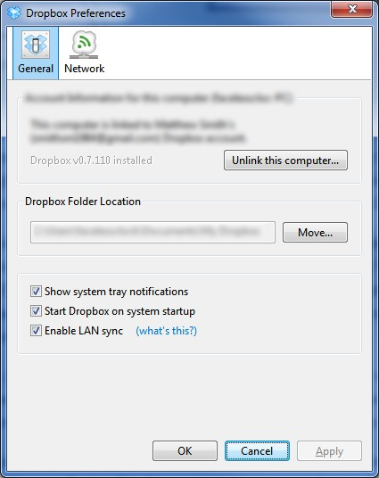

There is an option in the PC, Mac and Linux client’s Preferences window that lets you turn on LAN sync. This, however, does not bypass the need to have a constant connection to the Internet when syncing the folder. The LAN sync makes it possible for computers in your home network to directly transfer files, but a connection to the main Dropbox server is still required because only the server knows what folders and files need to be transferred, moved or deleted. The client that you have installed on your computer is effectively brain-dead without the main Dropbox server.

File Sync on Mobile Devices

As mentioned earlier, Dropbox is not limited to Windows, OS X and Linux based computers. The company has rolled out clients – or apps, as smartphone lovers like to call them – for the iPhone, iPad and Android based smartphones.

The basic nuts-and-bolts are a bit different from the computer clients. Once you’ve downloaded the app you’ll need to log in to your Dropbox account or set one up if you don’t already have one. However, because of the space limitations, it isn’t ideal (or possible, in many cases) for your device to download the entire folder; instead,
the default settings of the apps only let you view your folder. If you’d like to actually

download a file you need to mark it as a “favorite” – only then will the app make that file viewable while offline.

Because the Dropbox apps never actually download your folder or its contents (unless a file marked as a favorite) these apps require an active Internet connection. Wireless, 3G or 4G will be suitable for this task, but if you don’t have access to the
Internet via any method of connection you will only see your “favorites.”

Exercise caution when downloading files from your Dropbox account, keeping the data limit on your wireless plan in mind. Many plans have limits of just a couple gigabytes a month. That will let you view numerous mobile websites, but you can blow through that cap in a matter of hours if you’re continually downloading files from Dropbox to your device.

Chapter 3: The Web Interface

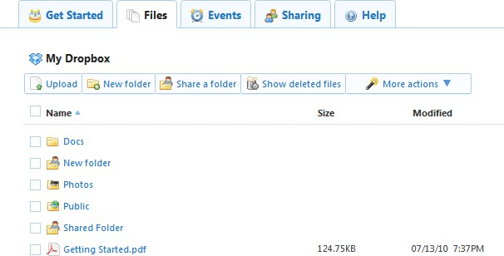
Logging in and Exploring the Web Interface
Dropbox clients make it easy to handle the sharing of files in your Dropbox folder, but the web interface is a critical part of the service’s overall functionality. It makes it possible to access your folder on a computer without installing a client, and is also
responsible for controlling some of the service’s settings.

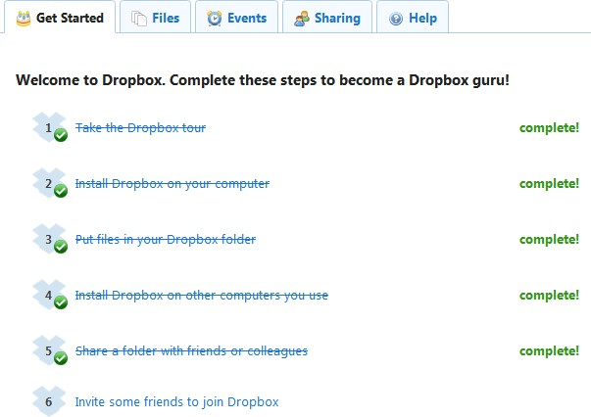
The web interface can be accessed by going to Dropbox.com and logging in to your account. Once you’ve logged in you will be brought to page with five tabs at the top. The tabs are, from left to right: Get Started, Files, Events, Sharing and Help.

You’ll find that the Getting Started tab is opened by default if this is your first time
logging in to the web interface. This tab doesn’t control any critical functionality but instead acts as a basic tutorial. You can see a video introduction to Dropbox’s features and perform a variety of basic tasks, such as placing files in your folder and installing Dropbox on various devices.

If you complete all of the basic tasks in the Get Started tab you will be rewarded with an extra 250MB of storage space. Hurray! After you performed those tasks you can further increase your storage limit by referring friends. You earn 250MB for each friend who joins up, to a limit of 8GB.

Accessing Files and Folders with the Web Interface
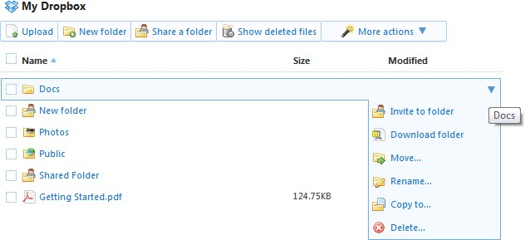
The Files tab in the web interface will bring you to your Dropbox folder. This folder is exactly the same as the folder on your devices; any files that you’ve placed into your folder on your computers are accessible through this part of the web interface.

When you click on a file in the web interface your browser will make an effort to open it. This is simple if the file in question is a common text or image file, but your success with more complex files will obviously be limited.

You can download files using two different methods. If you simply want to download a single file you need to hover your mouse over the file in question. The file will become highlighted and a drop-down menu will appear on the right. If you click that arrow a list of options will appear, one of which is the Download File option. It does what you’d expect. You can also download an entire folder using this method: folders are retrieved as .zip files

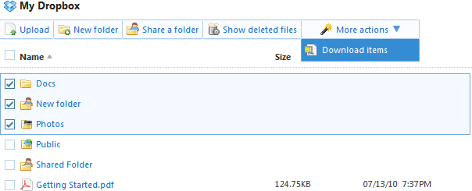

Multiple files in a folder can be retrieved by clicking on the checkboxes to the left of the files you want to download. Once you’ve selected the files you can click on the More Actions drop-down menu in the upper right and then click Download Items.

You can also manage files and folders just as you would in a normal local folder. You can place files into a folder by clicking on the file and dragging it to the folder you’d like to place it in. It is also possible to delete, rename or move files by highlighting them with your mouse cursor and then using the drop-down menu on the right. New folders can be created and files can be uploaded by using the toolbar that appears just below the My Dropbox icon.

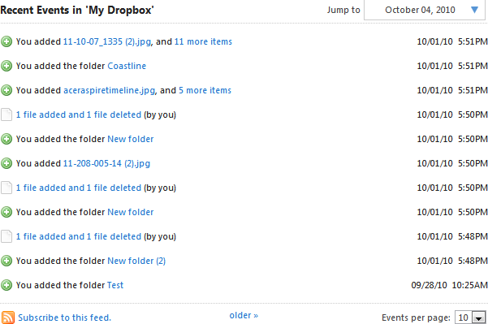
Events, Sharing and Help!
The middle tab of the Dropbox web interface is the Events tab. This shows you all of the recent activity that has taken place on your account. This includes a wide variety of data such as the addition and deletion of files, moving files, adding and removing folders, sharing files and folders, linking computers to your account and more.

You may never need to use the Events tab, but it comes in handy if you want to take a look at your recent activity in order to remember a change that you made or find a file that you’ve misplaced. The Events page can show up to 50 events at a time, and you can also sort events by date.
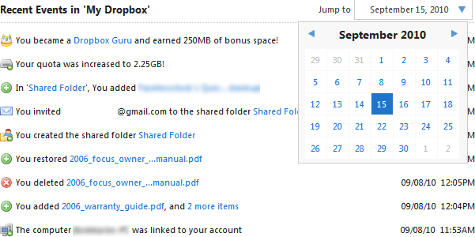
The fourth tab from the left is Sharing. This is where you’ll find all of the options related to sharing files with Dropbox. (see Chapter 4: Using Dropbox for File Sharing for more information.)
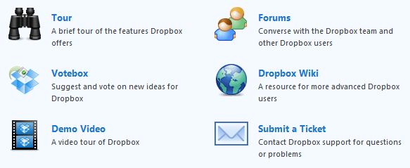
Last, but not least, is the help tab. This is where you’ll find all of the information that Dropbox has provided for you about the service, as well as links to the Dropbox wiki and forums. This guide is designed to acquaint you with the Dropbox service, but the forums are a great place to check out if you have continuing questions or technical difficulties that you’re unable to resolve.

Chapter 4: File Sharing

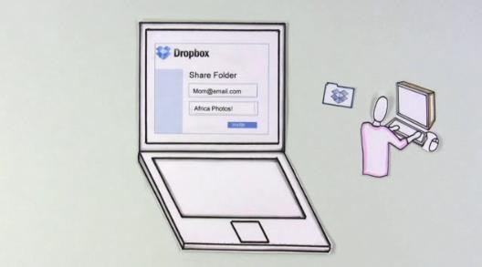
The Basics of Dropbox File Sharing
One of the major features of Dropbox is file sharing, a natural extension of the service. Dropbox already syncs all of the files that you want to make accessible for your own use on any device. Why not also make it easy to share those files with everyone else?

Obviously, the storage limits on Dropbox accounts are going to limit what you can do with this feature. This is not meant to be a service that you use to share your music folder or your favorite movie. The file sharing features are simply meant to make it easy to share limited amounts of information with your friends. The introduction video on the Dropbox.com front page suggests using the service to share travel photos with friends – a great example of what the service is for.

There are two ways to share the information in your Dropbox folder: through the use of the Public folder and by sharing a folder with specific email addresses.

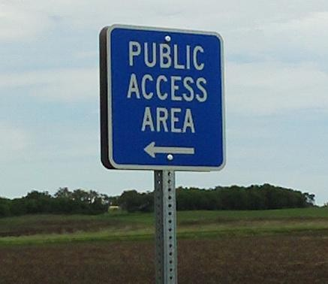
Public Folder File Sharing
Let’s say that you want to share a single photograph with a bunch of people. Perhaps the photo is related to an event you went to and you want to share it with everyone on your Twitter account.

This is what the Public folder is all about. As explained in Chapter 2, the Public folder is automatically part of your Dropbox folder when you start an account. It is the only folder that automatically creates a public link to every file it contains.

The term “public” is a bit loose here. Anyone who has a link to a public file can share it with anyone they’d like, and it is theoretically possible that someone could guess the link to a file in your Public folder even if you never shared that link with anyone.
That’s not likely, however – files in your Public folder can generally be considered private until you share them. Still, if you took some photos of yourself streaking down Main Street during a night of drunken debauchery it is probably a good idea not to place them in your Public folder.
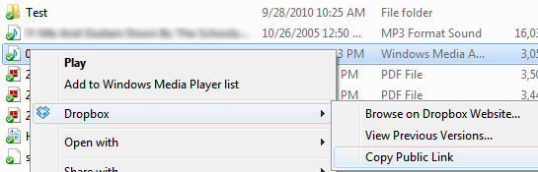
You can find the link to a file in your Public folder in two ways. If you have a Dropbox client installed on PC, Mac or Linux computer you can right-click on the file, navigate to the Dropbox menu, and then click Copy Public Link. This will place the link to your file in your clipboard so you can paste it into any web browser. Files that your browser can open, such as video files and pictures, will open automatically.
Files the browser can’t open will be available for download instead.

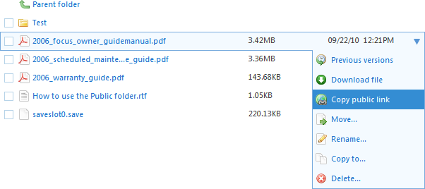
Sharing files in this manner is also possible if you’re using the web interface. Simply open the Public folder and then place your cursor over the file you want to share. Click on the drop-down menu that appears to the right and then click on Copy Public Link. The link won’t be copied to your clipboard automatically: a prompt displaying the full link address will appear in your browser.

Please note that files in your Public folder may take a few moments to become available. If you place a file into the Public folder and try to view it immediately you might be greeted by a 404 File Not Found message. Don’t fret; check back after a few minutes.

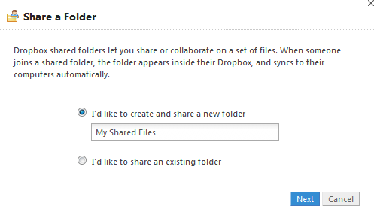
Sharing Files with Individuals
The Public folder is awesome if you want to make a file publically available via Twitter or Facebook, but it’s not so awesome if you want to share a somewhat private file or if you want to share a huge number of files with specific people.
Fortunately, Dropbox also lets you share any sub-folder in your Dropbox folder with individuals of your choosing.

Unlike the Public folder, which is made available by default, there are not any default folders set aside for sharing with specific individuals. In order to do this you need to create a brand new sub-folder. As with most things in Dropbox, you can do

this either by creating the sub-folder in the local copy of your Dropbox folder or you can create it using the Dropbox web interface. The new folder will then sync with the service. You’ll need to right-click on the folder and then navigate to the Dropbox options menu, under which you’ll find the Share This Folder option. This will open up the Dropbox web interface.
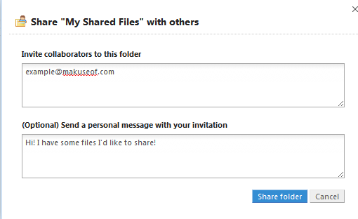
At this point you will need to enter the email address of everyone you’d like to share the folder with. You can also add a message that will be sent in the body of the email. Once you’re done click the Share Folder button. The people you’ve shared the folder with will have to sign up for a Dropbox account to view it.

You can also share folders in the web interface by clicking the Share a Folder button on the toolbar. You can create a new folder, or share an existing one. After you click the Next button you’ll be taken to the same prompt explained in the paragraph above.

The person who receives the shared folder will have to accept the folder once
they’ve signed up for and/or logged into their Dropbox account. All file actions are available to everyone who has access to a shared folder. In other words, anyone you’ve shared the folder with can delete everything in the folder. This will be recorded in the Events tab of the web interface and can be rolled back, an action that will be discussed in the next chapter.

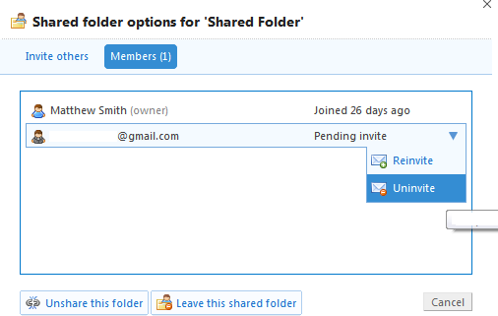

While you can’t restrict what other people can do to the files you share, you can kick people out of the shared folder at any time. You can accomplish this by going to the Sharing tab in the web interface, clicking on the Options link, and then clicking on the Members tab. A list of everyone with access to the folder will appear. Simply use the drop-down menu next to an individual’s name to give them the boot. You can also unshare the folder by clicking the link at the bottom of that webpage.

Chapter 5: Online Backup

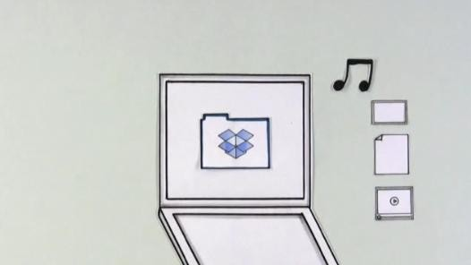
The Pros and Cons of Online Backup
As the introductory video suggests, you can use Dropbox as a backup service. Online backup services are common these days – if Dropbox didn’t offer file syncing it would be in direct competition with companies like iDrive and Carbonite.

Using Dropbox for the task of backing up data has both pros and cons. The main advantage of online backup is the fact that your files are hosted at a remote location that is entirely separate from your physical location. Most people who back up data transfer it to an external hard drive. That’s fine, but what if your house burns down or there is a flood? Your equipment would be ruined and your data would go with it.

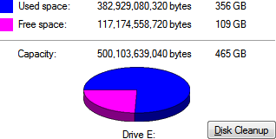
You can also use Dropbox to backup information that is located on multiple computers with a single service. This is much more convenient than plugging an external hard drive into your desktop, transferring, unplugging it, plugging it into your laptop, transferring, and – I think you get the picture.
Of course, there are some disadvantages as well. Backing up large amounts of data is difficult because of the storage limitations on a Dropbox account. Even the $19.99 monthly plan only offers 100 gigabytes of storage, which is nothing if you want to

backup music and movies. Another problem: your backup is tied to an account that could theoretically be hi-jacked.

Handling Space and Security

Dropbox’s relative ease of use can make it an appealing method of backing up information, but storage space is an issue. None of the available accounts, free or paid, offer a massive amount of storage.
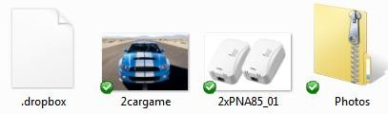
The limited storage space is not insurmountable, however. One way to overcome it is by making heavy use of .zip files. Zip files are compact folders that compress files, reducing the storage space they consume. The trade-off is accessibility – you have to decompress the files in the .zip folder before you can open them. Most modern computers can handle this task in seconds, but the time required to unzip a folder will depend on the level of compression and the speed of the computer you’re using.

Another way to side-step the storage space limitation is to be selective about what you back up. Do you really need to backup the software installed on your computer? Do you really need to backup every single image or music file you have on your computer? Sorting through your files and picking the ones that are important can be difficult, but it will reduce the data you need to backup.

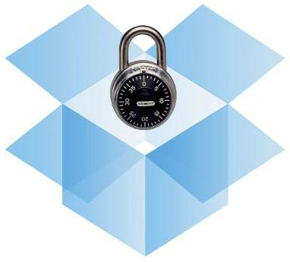

Security is also an issue that can impact Dropbox (and any other online storage service).

Storing your information online is handy and provides an off-site backup that you can access in the event of a major catastrophe. However, backing up your data online makes it accessible to anyone who knows your username and password. You can improve your security by choosing a password that would be difficult to guess and limiting access to Dropbox to secure connections, but there is always going to be some risk involved. Dropbox may not be the best choice of backup solution if you need to backup sensitive data, such as bank e-statements or last year’s tax returns.

Using the Undo/Undelete Feature

One of the reasons why Dropbox can be a nice backup solution is its easy to use undo/undelete functionality. Accessed via the web interface, this feature lets you reverse changes that you make to a file in your Dropbox account. This lets you retrieve a file if you accidently delete it.

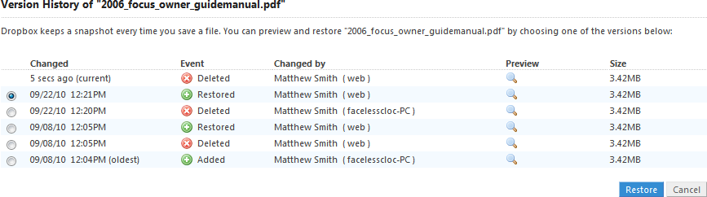
One way to undo a file deletion is through the Events tab of the Dropbox web interface. The Events tab, as explained earlier, lists recent actions that impacted your account, including the deletion of files. This is represented by a small red-and- white X icon and the text “You deleted [filename].” If you deleted multiple files on
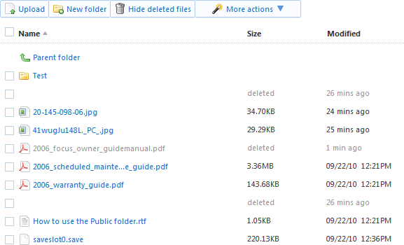
the same day that text will be followed by “and other items,” which can be clicked to reveal all of the files (or folders) deleted on that day. You’ll then be able to restore files by clicking on the radio button listed next to the appropriate file and clicking the Restore button. Alternatively, you can attempt to simply view the file.
You can also view deleted files while you are browsing your folders if there are any available to be retrieved. This is done by clicking the Show Deleted Files button. Files in this view will show how long ago they were deleted, but folders will not show that information. If you deleted multiple files you may need to use the Show Deleted Files button to retrieve everything that was deleted.

Chapter 7: Advanced Dropbox Tricks

Syncing Calendars, Email and More

Most folks who use Dropbox simply use it to sync basic files they’d like to have accessible on all of their mobile devices. I personally find it to be a handy way of making all of my writing accessible on all of my computers. It is much easier to let Dropbox sync the drafts of this guide to my computers than to constantly send myself emails.

Syncing documents, however, is just the tip of the iceberg. Dropbox isn’t picky about what it syncs. Stick a file in Dropbox and zam! – it’s instantly sent to your other devices. This includes files like bookmarks, calendar databases and email databases.
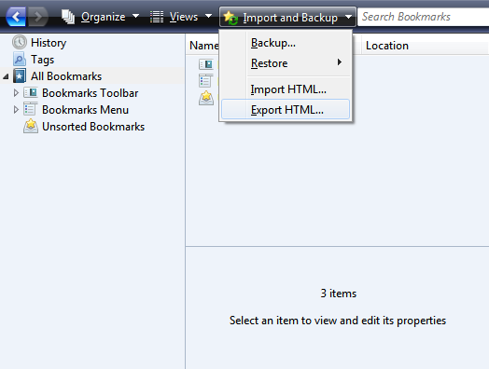
In effect, you can use Dropbox to sync client software that relies on a local file to store information. Any software that has the capability to export or import the information used by the software can take advantage of Dropbox. This includes browsers like Firefox and Internet Explorer, calendar applications, financial applications and much more. Taking advantage of this functionality can make it much easier to keep software installed on different computers in sync. Just change your software’s settings so that such information is stored in the Dropbox and you’re good to go.

Using Dropbox as a Remote Control

Dropbox doesn’t require much user interaction to sync files. If you drop a file in the Dropbox folder on any computer linked to your account that file becomes available on all your computers and devices. The computers receiving the data do not have to take any action in order to have the folder updated, and no notification appears when a new file is uploaded.
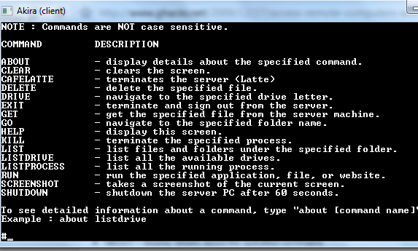
This means that you can use Dropbox to trigger actions on a computer that you are not currently using. The most powerful such program is Akira (http://macobex.wordpress.com/), a program that lets you control a computer remotely via Dropbox via a wide range of text commands.
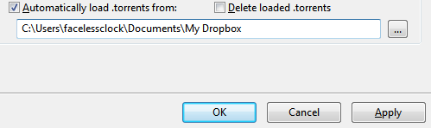
You can also remotely control a computer using Dropbox with any program that is capable of automatically taking an action when a file appears in a folder. Bittorrent clients are the most popular example of this. Most are capable of automatically beginning a torrent download if a torrent file is placed into a specified folder. This means that you can place the torrent file into your Dropbox folder from a remote computer and have that file begin downloading on your home PC.

Syncing Wikis and To-Do Lists

It is also possible to sync an entire wiki or to-do list using Dropbox. The most basic example of this, of course, is to simply throw a .txt file with your to-do list into the folder, but you can go much further than that. Your operating system does not consider your Dropbox folder to be any different from any other folder on your PC.

That means you can install a Wiki or To-Do program directly into the Dropbox folder and then use it as a fully synced entity.
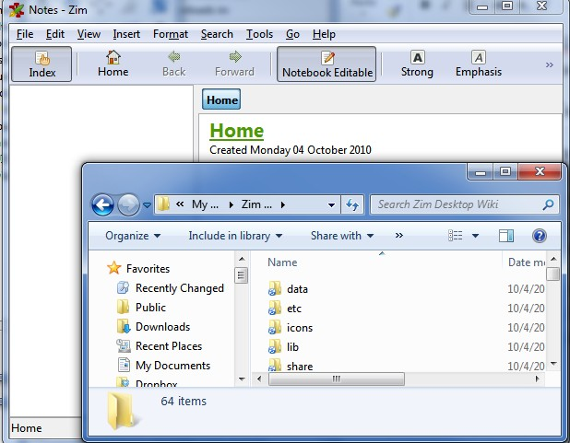
Let’s consider, for example, the Zim desktop wiki. This wiki installs on a computer and gives you a space that can be used to keep tabs on your life. You can add to-do lists, contact information, or use it to hold private journal entries and other thoughts. If you install Zim directly into your Dropbox folder your wiki will be automatically synced among all of your devices. This ensures that you always have your
information at your fingertips no matter what device you’re using. Zim, of course, is just an example – there are a lot of personal wiki options available and any of them should be usable alongside Dropbox.

Other Tips, Tricks and Hacks

There are far too many tips and tricks to list in-depth in this section. The Dropbox community is vibrant, and is constantly coming up with new and innovative ways to use the product. With that said, however, here are some other advanced tricks you should look into if you want to customize Dropbox.

- AirDropper (http://www.airdropper.com/) – This web app lets you request files from folks that don’t have a Dropbox account. This is very handy if you need
to receive a file quickly from someone who doesn’t have and/or doesn’t want to install Dropbox.
- DropBoxen (http://wiki.dropbox.com/DropboxAddons/Dropboxen) – Makes it possible to launch multiple Dropbox instances on a single PC. Obviously this isn’t going to be well liked by Dropbox, since you can use it to side-step the need to subscribe; use it at your own risk.

- Dropbox Buddy (http://cid- f2f6d5f64481dc88.skydrive.live.com/browse.aspx/.Public) – An advanced remote control suite that makes it possible to transfer files both ways from a remote computer and also take certain actions, such starting or terminating programs.
- DropBoxPath (http://forums.dropbox.com/topic.php?id=9665) – This hack lets you change the location of your DropBox folder.
- Dropbox Dashboard Widget ((http://wiki.dropbox.com/DropboxAddons/Dropbox%20Dashboard%20Widg et) – For Macs, this adds a widget that you can drag files into in order to automatically copy them to your Dropbox public folder.
All of the tricks listed above can be found on the Dropbox wiki (http://wiki.dropbox.com/DropboxAddons), and there are numerous other niche tricks and hacks that can be very handy. You can email files to Dropbox, use DropBox to host a photo gallery or even web page, and use Ruby scripts as a methods of DropBox interaction, so be sure to check that site out.

Chapter 8: Conclusion

Additional Dropbox Reading
This Dropbox manual is meant to bring you up to speed with the features that are available in Dropbox. By the time you’ve reached this conclusion you’ll know how Dropbox works, how to use it for file sharing and how to use it as a backup solution.

Dropbox is, in stock form, extremely useful. Even better: it is surrounded by a large and rapidly growing community that is constantly churning out new ways to extend its functionality. If you’re interested in learning more tips and tricks about Dropbox you should check out the following Makeuseof.com articles:
- Five Cool Apps That Make Dropbox Even More Useful http://www.makeuseof.com/tag/5-applications-dropbox/
- Five Tips To Use Dropbox As The Perfect Writing Environment

http://www.makeuseof.com/tag/tips-dropbox-perfect-writing-environment/
- Four Unique And Cool Ways To Use Dropbox http://www.makeuseof.com/tag/four-ways-to-integrate-the-dropbox-file- sharing-program-into-your-life/
- DroppedBoxx – An Unoffical Dropbox Client For Windows Mobile http://www.makeuseof.com/tag/droppedboxx-unofficial-dropbox-client-windows- mobile/
- How To Run Multiple Dropbox Accounts Simultaneously [Mac] http://www.makeuseof.com/tag/run-multiple-dropbox-accounts- simultaneously-mac/
- How To Use Dropbox As A Free Unblockable Image Storage For Your Blog

http://www.makeuseof.com/tag/dropbox-free-unblockable-image-storage-blog/
- Three Reasons Why Students Should Be Using Dropbox http://www.makeuseof.com/tag/3-reasons-why-students-should-be-using- dropbox-as-a-study-tool/
- Using Dropbox As An iPad Finder App http://www.makeuseof.com/tag/dropbox- finder-ipad-mac/

Competitors and Alternatives

Dropbox is awesome, but no program is best for everyone. You may, after using Dropbox, decide that you like the idea but the functionality of this service and the implementation just isn’t doing it for you. Perhaps you don’t like being tied down to a central server, or find the monthly access fees for paid accounts a bit expensive.
Don’t fret – there are some alternatives worth checking out.

- SpiderOak (http://www.makeuseof.com/tag/spideroak-online-data-backup- sharing-solution-crossplatform/) – Slanted towards file backup as well as sharing, SpiderOak isn’t nearly as easy to use as Dropbox despite the
interface’s best efforts. However, SpiderOak’s storage plans are incredible – you only have to pay $10 monthly for a storage capacity of 100GB, which is half what you’ll pay for a 100GB Dropbox plan.
- SugarSync (http://www.makeuseof.com/dir/sugarsync/) – Very similar to Dropbox, SugarSync can keep file synced between multiple devices including both computers and mobile phones. SugarSync already offers official support for Blackberry, Windows Mobile and Symbian in addition to the iPhone, iPad and Android. SugarSync also offers better deals on data storage plans. Most reviews agree, however, that the service lacks the intuitive feel of Dropbox.
- Windows Live Sync (http://www.makeuseof.com/tag/sync-files-folders- computers-windows-sync/) – Microsoft’s sync solution doesn’t rely on a central server but instead lets computers sync directly with each other. It is quick, and there are absolutely no data limits because nothing is ever stored on a Microsoft server. However, the interface is more complex and computers can only sync files when they’re online simultaneously.

Happy Dropbox-ing!

And so we come to the end of the Big Book of Dropbox. I hope that this has served you well as a crash-course for the program. If you have any questions, however, check out Makeuseof Answers (http://www.makeuseof.com/answers/). Geeks are ready to help you solve whatever problem you might have.


Did you like this PDF Guide? Then why not visit MakeUseOf.com for daily posts on cool websites, free software and internet tips.

If you want more great guides like this, why not subscribe to MakeUseOf and receive instant access to 20+ PDF Guides like this one covering wide range of topics.
Moreover, you will be able to download free Cheat Sheets, Free Giveaways and other cool things.

Subscribe to MakeUseOf : http://www.makeuseof.com/join

MakeUseOf Links:

Home: http://www.makeuseof.com MakeUseOf Directory: http://www.makeuseof.com/dir MakeUseOf Answers: http://www.makeuseof.com/answers Geeky Fun: http://www.makeuseof.com/tech-fun
PDF Guides: http://www.makeuseof.com/pages/
Tech Deals: http://www.makeuseof.com/pages/hot-tech-deals

Follow MakeUseOf:

RSS Feed: http://feedproxy.google.com/Makeuseof
Newsletter: http://www.makeuseof.com/join
Facebook: http://www.facebook.com/makeuseof
Twitter: http://www.twitter.com/Makeuseof

Download Other MakeUseOf PDF Guides!
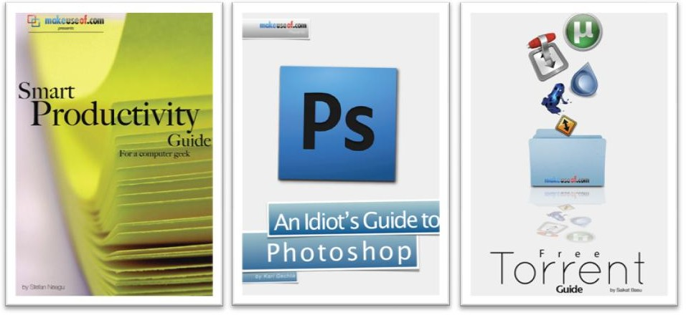


Subscribe to Download : http://www.makeuseof.com/join

Subscribe to Download : http://www.makeuseof.com/join
